**VIETNAM NATIONAL UNIVERSITY – HO CHI MINH CITY INTERNATIONAL UNIVERSITY**

**SCHOOL OF INDUSTRIAL ENGINEERING AND MANAGEMENT**

**ANALYSIS OF TRAFFIC CONGESTION AT DINH BO LINH - BACH DANG INTERSECTION IN HO CHI MINH CITY USING ARENA SIMULATION**

SIMULATION MODELS IN INDUSTRIAL ENGINEERING COURSE

**Lecturer: Dr. Pham Huynh Tram**

**Group Number: 08**

**Class: G02**

|  |  |  |
| --- | --- | --- |
| **Student ID** | **Member name** | **% Contribution** |
| **IELSIU21357** | **Nguyễn Văn Phong** | **100%** |
| **IELSIU21288** | **Văn Ngọc Hoàng Hải** | **100%** |
| **IELSIU21189** | **Dương Bình Dương** | **100%** |
| **IELSIU21334** | **Nguyễn Thị Bích Ngọc** | **100%** |
| **IELSIU21299** | **Lê Huy Hoàng** | **100%** |

Ho Chi Minh City, Vietnam

6/2024

# ABSTRACT

Traffic congestion at intersections is a common problem around the world, particularly in large cities where development is occurring swiftly and massively in the absence of suitable infrastructure. There are numerous factors that contribute to this predicament, one of which is that the distribution and adjustment of traffic lights is not truly rational in light of fluctuations in traffic intensity at different times of day.

That uncomfortable situation motivated our team to conduct research and make recommendations to help optimize time at traffic lights by using real-time data collection and including it in the Arena simulation. After surveying and zoning the area, our team decided to use the Dinh Bo Linh - Bach Dang intersection area, an important intersection with extremely high traffic density during the day in Ho Chi Minh City, as a case study for research on changing traffic light timing on a regular basis. The study uses data acquired from this intersection to display the data in terms of timetable and allocation, followed by simulations utilizing Arena software. Then we verify and validate the model to ensure it is appropriate, viable, and applicable. Finally, an analysis of the results will be offered, followed by recommendations for future enhancements and modifications to improve traffic flow at the intersection.

The end result revealed that several times over the timeframe, traffic concentrations were disturbingly high, producing congestion. As a result, one approach for preventing congestion is to set proper lengths of red and green lights, which can alter the queue and reduce congestion.

**Keywords:** Congestion analysis, vehicle flow, simulation model

# ACKNOWLEDGEMENT

We would like to extend our deepest appreciation to various individuals and institutions whose contributions have been critical to the successful production of this study.

First, we sincerely thank Dr. Pham Huynh Tram for her exceptional guidance, support, and expertise throughout this project. Dr. Tram's insightful feedback, knowledge and encouragement have significantly enhanced the quality of our work. Besides, we are also profoundly grateful to our teaching assistant, Ms. Hoa, for her dedicated assistance and unwavering support. Her prompt responses to support the team in fixing errors during the model building process and her thorough explanations have been instrumental in our understanding and progress.

Additionally, we would like to thank the School of Industrial System Engineering for granting us access to the ARENA software and supporting us to use the laboratory at a comfortable time. This resource has been critical for the simulation and analysis components of our project.

Lastly, we wish to acknowledge the hard work and collaborative efforts of all our team members. Their dedication and teamwork have been essential in bringing this project to fruition.

# TABLE OF CONTENTS

ABSTRACT ii

ACKNOWLEDGEMENT iii

TABLE OF CONTENTS iv

LIST OF FIGURES v

LIST OF TABLES vi

CHAPTER 1 INTRODUCTION 1

1.1 Background 1

1.2 Problem Statement 1

1.3 Objectives of the study 2

1.4 Scope and Limitations 2

1.5 Project planning 3

CHAPTER 2 RELATED WORK 4

2.1 Overview 4

2.2 Literature Review 4

2.3 Key References 4

CHAPTER 3 METHODOLOGY 5

3.1 Approach Comparison and Selection 5

3.2 Proposed Conceptualization Model 5

CHAPTER 4 INPUT MODELING 6

4.1 Data Collection 6

4.2 Major Assumptions 9

4.3 Fitted Distribution 9

CHAPTER 5 ARENA MODEL 20

5.1 Logic and Module 20

5.2 Verification and Validation 27

5.2.1 Verification 27

5.2.2 Validation 27

5.3 Experimental and output analysis 31

5.4 Result Discussion and Implications 33

5.5 Recommendation for Future Research 34

REFERENCES 35

APPENDIX 5.A

LIST OF FIGURES

Figure 3.2: Conceptual model 8

Figure 5.1 : Logic of traffic light 23

Figure 5.2 : Logic of flow vehicle at Dinh Bo Linh Route 23

Figure 5.3: Logic of flow vehicle starting at East Bach Dang Route 23

Figure 5.4 : Logic of flow vehicle starting at West Bach Dang Route 23

Figure 5.5 : Flow of station connected by routes 24

Figure 5.6 : The flow of the whole model 30

Figure 5.7 : Test model: Result in 1 hour run 31

Figure 5.8 : MAPE formula 31

Figure 5.9 : <Schedule Module > Declare total vehicle per hour 32

Figure 5.10 : <Variable Module> Try to assign distribution from input analyzer 33

Figure 5.11 : < Schedule module > Adjustment values in schedule module 33

Figure 5.12 : Test model : Improvement result by changing parameters.  34

Figure 5.13: OutputStats By Rep 36

Figure 5.14 : Tally stat in stations 37

Figure 5.15: The fluctuate of transport population 38

Figure 5.16: Counter station in 7 days 38

# LIST OF TABLES

Table 4.1: Data collected from observation 10

Table 4.2: Car distribution at South route  14

Table 4.3: Car distribution at East route  15

Table 4.4: Car distribution at West Route 16

Table 4.5: Motorbike distribution at South route  17

Table 4.6: Motorbike distribution at East route 17

Table 4.7: Motorbike distribution at South route  18

Table 4.8: Bus distribution at South route  19

Table 4.9: Bus distribution at East route  21

Table 4.10: Bus distribution at West route  22

Table 5.1: Logic and modules of Traffic light operation 24

Table 5.2: Logic and modules of the flow for vehicle starting at Dinh Bo Linh Route 25

Table 5.3: Logic and modules of the flow for vehicle starting at East Bach Dang Route 27

Table 5.4: Logic and modules of the flow for vehicle starting at West Bach Dang Route 28

Table 5.5: Logic and modules of flow of stations connected by routes 29

# INTRODUCTION

## Background

Arena is a discrete event simulation and automation software developed by Rockwell Automation. It allows users to model the operation of systems in a visual, graphical environment. Users can simulate different processes to predict their performance and identify potential improvements. This software is particularly popular in operations research and industrial engineering for analyzing complex systems and processes. Arena is a useful tool since it can resolve real-life problems such as process optimization, cost reduction, capacity planning, risk management, transportation and logistics.

The chosen intersection is the intersection of two major roads, Dinh Bo Linh and Bach Dang, connecting the city center with gateway areas. Dinh Bo Linh - Bach Dang crossroad is widely known because of its high vehicle rate and prolonged traffic jams, especially during peak hours. This is the bottleneck of traffic flow when vehicles go from Binh Trieu Bridge to Dinh Bo Linh Bridge. The traffic jam usually occurs at 6 to 9 am and 4 to 6 pm, the congestion last for nearly 1 km in length.

The traffic congestion rate at Dinh Bo Linh - Bach Dang intersection is higher than other intersections in Ho Chi Minh City since Binh Thanh District is densely populated. The reason behind this is many universities, colleges, and high schools are located in Binh Thanh, various types of vehicles like buses, motorcycles, cars, large trucks crossing the area in the discipline route so traffic jams occur frequently in the area.

## Problem Statement

Recently, traffic jams in Ho Chi Minh City have become quite complicated. People jostling with each other, moving little by little with loud car horns, combined with the stuffy atmosphere of after-work hours, makes millions of Ho Chi Minh City people haunted every time they have to pass through a traffic jam. According to a report from the Ho Chi Minh City Department of Transport, it is estimated that the city loses 140,000 billion VND every year just because of traffic congestion. Not a solution has been applied to solve the traffic congestion at Dinh Bo Linh - Bach Dang intersection, the bottleneck scenario occurs frequently at the pier of Dinh Bo Linh Bridge due to small space and high vehicle rate. In this group project, our group aim is to simulate the vehicle routing at Dinh Bo Linh - Bach Dang intersection by using the Arena applications then decide on which amount of traffic light time will optimize the congestion time along with reducing traffic jams in this area.

## Objectives of the study

This project aims to build a functional simulation model, which is used to develop the optimized result and simulation of the traffic flow of Dinh Bo Linh - Bach Dang intersection in Binh Thanh District, Ho Chi Minh City. We formulate a clear question or hypothesis to guide their investigation. With the information and data collected from real life, this project will examine the operational process with analytical data to determine the best optimal solution to this problem. We use various methods (experiments, case studies) to collect data. Data is analyzed to draw conclusions and answer the research question.

Additionally, this project gives students the chance to learn more specifically and in-depth information about simulation, improve their capacity to handle real-world issues, and become acquainted with careers in the logistics sector.

## Scope and Limitations

***1.4.1. Scope***

The study focuses on the traffic flows of the vehicles circulating on Dinh Bo Linh - Bach Dang intersection, Binh Thanh district, Ho Chi Minh City, considering real-world traffic conditions by applying specialized knowledge and skills in Simulation Models in Industrial Engineering.

Data analysis and simulation about the intersections will be performed using MATLAB and Arena Simulation. We will explore various scenarios and evaluate their impact on congestion. The model illustrates the performing traffic flows and time at each direction of the intersection and describes the optimal solution to the problem.

***1.4.2. Limitations***

During building the simulation model to illustrate the traffic flows of Dinh Bo Linh - Bach Dang intersection, there are still numerous limitations presented below:

* Assumptions: The model relies on certain assumptions about driver behavior, road conditions, and traffic signals.
* Simplifications: To make the analysis feasible, some simplifications may be necessary.
* Specific Conditions: The study considers a particular intersection; results may not generalize to all intersections.
* Practicality: Because the model is assumed with perfect efficiency (no failures should be considered), calculating the time and human resources to work is just theoretical. Such figures may not be accurate and should be taken into account with breakdowns and other disruptions to get a holistic view of the operation.

## Project planning

* Objective Definition: Clearly defining the goal of the study, which in this case is to systemize traffic lights considering traffic density to minimize idle time.
* Data Collection: Gathering data on traffic flow, signal timings, and intersection layouts.
* Simulation Modeling: Using MATLAB to analyze waiting times and ARENA for discrete event simulation.
* Parameter Analysis: Determining the range of variables like cycle time, effective green time, and traffic arrival rate1.
* Simulation Runs: Conducting multiple simulation runs to test different scenarios and collect results.
* Result Analysis: Comparing the simulation outcomes with real-world data to validate the model.
* Optimization: Adjusting parameters to find the optimal settings for traffic lights.
* Documentation: Writing the research article with detailed methodology, results, and conclusions.

# RELATED WORK

## Overview

The project focuses on traffic congestion at a single intersection and explores methods to analyze and optimize it using MATLAB and ARENA simulation tools. It aims to address the challenges of traffic jams by proposing a model that can improve traffic flow and reduce waiting times.

## Literature Review

This project has reviewed extensive literature on traffic congestion, proposed a method to optimize traffic lights by considering traffic density, aiming to reduce idle time and improve traffic flow particularly by using utilized simulation tools like MATLAB and ARENA. It highlights the limitations of traditional traffic light systems that operate on fixed intervals, which fail to adapt to varying traffic densities and times of the day.

* Previous Research: The project references previous studies on traffic control and congestion, such as the work by Tay and Lee on traffic conditions during road construction and operation stages, and Papageorgiou et al.'s review of road traffic control strategies.
* Current Contributions: The project contributes by analyzing traffic flow using MATLAB and ARENA simulations, providing a method to estimate traffic congestion based on idle time ranges derived from cycle time, effective green time, and traffic arrival rate.
* Research Gap: The study identifies a gap in the ability of current traffic light systems to adapt to real-time traffic conditions and proposes a solution to systemize traffic lights based on actual traffic density.
* Problem Addressed: The problem tackled is the inefficiency of fixed-interval traffic lights at Dinh Bo Linh - Bach Dang intersection, Binh Thanh district, Ho Chi Minh City.

Prediction Tested: The paper predicts that by using the proposed simulation models, traffic flow can be optimized, reducing waiting times and improving overall traffic management at intersections.

## Key References

To finalize the project, numerous sources were researched and utilized. The most important instance is the article "Analysis and Optimization of Traffic Congestion at Single Intersection Using MATLAB and Arena Simulation" by a group of authors: Rakesh Roy, Sourav Kumar Ghosh, Naurin Zoha, and Mohammad Arif-Ul-Islam (2020). This article significantly guided our project and motivated us to dedicate our efforts to fulfill the project objectives.

Additionally, we found the great support from related papers :

* **"Traffic Flow Theory: A State-of-the-Art Report" by the Transportation Research Board (TRB)**: This comprehensive report provides an in-depth overview of traffic flow theories and models, offering foundational knowledge crucial for understanding and analyzing traffic congestion.
* **"Modeling and Simulation of Traffic Flow and Traffic Management" by Peter Wagner (2012)**: This book provides detailed methodologies and case studies on traffic flow modeling and simulation, aiding in the development and validation of our traffic simulation models.

# METHODOLOGY

## Approach Comparison and Selection

Research published in the "Journal of Engineering and Applied Science" demonstrates that the Arena Simulator is ideal for simulating traffic flow at intersections. The study focused on the Mergan 4-way intersection and found that Arena successfully records traffic congestion and optimizes traffic flow. By comparing it to MATLAB simulations, the study determined that Arena produced comparable results, proving its effectiveness for this application. The study highlights Arena's capability to model complex traffic scenarios and improve intersection management through discrete event simulation. Therefore, our group has decided to apply Arena in the project in order to achieve best results.

## Proposed Conceptualization Model

*Figure : Conceptual model in general*

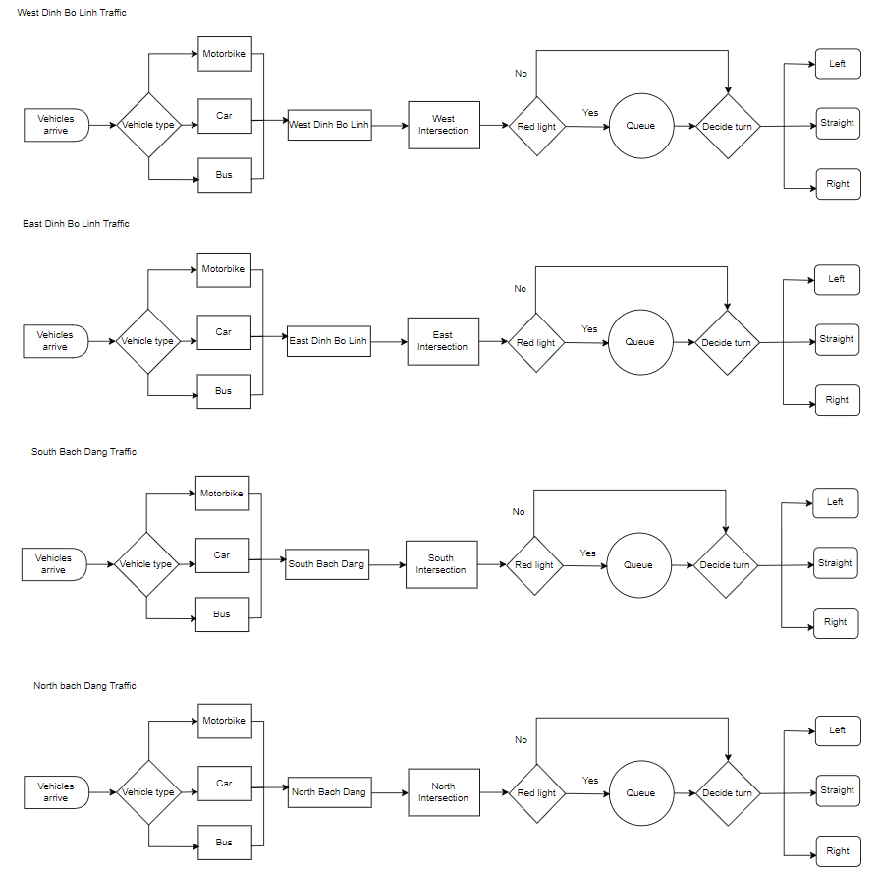

Figure 3.2: Conceptual model

# INPUT MODELING

## Data Collection

Data used for this project is the traffic volume moving at the intersection during the period of the day. We collect data of vehicles traveling on Bach Dang - Dinh Bo Linh crossroads by observing vehicle traffic on traffic cameras on the Ho Chi Minh City Portal website (http:/ /giaothong.hochiminhcity.gov.vn/). However, because the image quality from traffic cameras is not the best, it is difficult to give the exact figure for the data (the frame speed of the camera is very low). The traffic flow will be observed for 16 hours (from 6 A.M to 10 P.M), and we also divided 16 hours into 6 relevant time intervals such as 6 A.M to 7 A.M, 7 A.M to 8 A.M, etc. Each time interval, we will observe within 1 hour, estimate to see when the high and lowest car flow, then the average of Max and Min, from which we will get the average car flow in 1 minute, then times with 60 to obtain a car flow in 1 hour.

*Table 4.1: Data collected from observation*

|  |  |  |  |  |  |  |
| --- | --- | --- | --- | --- | --- | --- |
| **Time** | **Vehicle type** | **East** | **West** | **South** | **North** | **Traffic light duration** |
| 6 a.m-7 a.m | Bike | 1800 | 325 | 1200 | 1400 | 40s |
| Car | 5 | 3 | 9 | 7 |
| Bus | 450 | 13 | 225 | 300 |
| 7 a.m-8 a.m | Bike | 1500 | 113 | 1875 | 1950 | 40s |
| Car | 345 | 93 | 360 | 300 |
| Bus | 6 | 3 | 11 | 14 |
| 8 a.m-9 a.m | Bike | 1470 | 420 | 1650 | 1575 | 40s |
| Car | 270 | 103 | 225 | 315 |
| Bus | 8 | 2 | 23 | 10 |
| 9 a.m-10 a.m | Bike | 1236 | 420 | 1650 | 1575 | 40s |
| Car | 230 | 103 | 225 | 315 |
| Bus | 9 | 2 | 23 | 10 |
| 10 a.m-11 a.m | Bike | 3760 | 3940 | 6124 | 5640 | 45s |
| Car | 230 | 103 | 225 | 315 |
| Bus | 9 | 2 | 23 | 10 |
| 11 a.m-12 a.m | Bike | 3720 | 6340 | 5160 | 5820 | 50s |
| Car | 570 | 915 | 360 | 805 |
| Bus | 35 | 0 | 136 | 31 |
| 12 a.m-1 p.m | Bike | 2100 | 6121 | 3560 | 3840 | 55s |
| Car | 570 | 915 | 360 | 805 |
| Bus | 35 | 0 | 136 | 31 |
| 1 p.m-2 p.m | Bike | 1962 | 5521 | 3212 | 4012 | 55s |
| Car | 632 | 851 | 345 | 678 |
| Bus | 35 | 0 | 120 | 26 |
| 2 p.m-3 p.m | Bike | 2852 | 2695 | 2503 | 2310 | 70s |
| Car | 428 | 404 | 376 | 347 |
| Bus | 71 | 67 | 62 | 58 |
| 3 p.m-4 p.m | Bike | 3508 | 3024 | 2646 | 2437 | 70s |
| Car | 526 | 454 | 397 | 366 |
| Bus | 87 | 75 | 66 | 61 |
| 4 p.m-5 p.m | Bike | 16185 | 14465 | 13047 | 11807 | 70s |
| Car | 2429 | 2171 | 1958 | 1772 |
| Bus | 403 | 360 | 325 | 294 |
| 5 p.m-6 p.m | Bike | 3780 | 2512 | 9008 | 11520 | 65s |
| Car | 780 | 312 | 111 | 423 |
| Bus | 63 | 53 | 62 | 85 |
| 6 p.m-7 p.m | Bike | 6180 | 1840 | 7234 | 14760 | 55s |
| Car | 1320 | 120 | 211 | 3060 |
| Bus | 180 | 32 | 164 | 462 |
| 7 p.m-8 p.m | Bike | 1510 | 1236 | 3512 | 8623 | 50s |
| Car | 362 | 96 | 246 | 235 |
| Bus | 23 | 5 | 35 | 32 |
| 8 p.m-9 p.m | Bike | 1854 | 2154 | 2854 | 4519 | 50s |
| Car | 128 | 231 | 285 | 361 |
| Bus | 21 | 7 | 6 | 15 |
| 9 p.m-10 p.m | Bike | 1251 | 1845 | 1694 | 2815 | 50s |
| Car | 278 | 94 | 116 | 154 |
| Bus | 0 | 0 | 0 | 0 |
| 10 p.m-11 p.m | Bike | 1735 | 618 | 814 | 2149 | 50s |
| Car | 315 | 81 | 69 | 169 |
| Bus | 0 | 0 | 0 | 0 |

## Major Assumptions

In our model, we assume that:

* 80% of the time the model will work under normal conditions.
* In the remaining 20%, there will be special events occurring on the route such as accidents, rain, sports activities, which can cause frequent traffic jams on the route and increase waiting time for red light of the vehicles.
* The arrival rate follows the above dataset and the difference between periods is neglectable or follows exponential distribution like the first day.
* The system has a traffic light for intersections, assuming that real traffic lights are the same.
* The probability of which direction to turn depends on our observations.
* Vehicle index (1 – car, 2 – motorbike, 3 – bus)
* Vehicle Turning Right (1 – not turning right, 2 – turning right)

## Fitted Distribution

The fitted distribution of 9 collected datasets with the Histogram and details on Distribution

Summary, Chi Square Test, Kolmogorov-Smirnov Test (K-S test), Data Summary, and Histogram Summary calculated by the Input Analyzer tool in ARENA are shown in these tables below:

*Table 4.2: Car distribution at South route*

|  |  |  |
| --- | --- | --- |
| Observed data | | Car volume at South Route |
| Time interval | Volume |  |
| 6 a.m-7 a.m | 450 |  |
| 7 a.m-8 a.m | 345 |
| 8 a.m-9 a.m | 270 |
| 9 a.m-10 a.m | 230 |
| 10 a.m-11 a.m | 908 |
| 11 a.m-12 a.m | 832 |
| 12 a.m-1 p.m | 570 |
| 1 p.m-2 p.m | 632 |
| 2 p.m-3 p.m | 428 |
| 3 p.m-4 p.m | 526 |
| 4 p.m-5 p.m | 2429 |
| 5 p.m-6 p.m | 780 |
| 6 p.m-7 p.m | 1320 |
| 7 p.m-8 p.m | 362 |
| 8 p.m-9p.m | 128 |
| 9 p.m-10 p.m | 278 |
| 10 p.m-11 p.m | 315 |

*Table 4.3: Car distribution at East Route*

|  |  |  |
| --- | --- | --- |
| Observed data | | Car volume at East Route |
| Time interval | Volume |  |
| 6 a.m-7 a.m | 300 |  |
| 7 a.m-8 a.m | 300 |
| 8 a.m-9 a.m | 315 |
| 9 a.m-10 a.m | 315 |
| 10 a.m-11 a.m | 720 |
| 11 a.m-12 a.m | 1280 |
| 12 a.m-1 p.m | 805 |
| 1 p.m-2 p.m | 678 |
| 2 p.m-3 p.m | 347 |
| 3 p.m-4 p.m | 366 |
| 4 p.m-5 p.m | 1772 |
| 5 p.m-6 p.m | 423 |
| 6 p.m-7 p.m | 3060 |
| 7 p.m-8 p.m | 235 |
| 8 p.m-9p.m | 361 |
| 9 p.m-10 p.m | 154 |
| 10 p.m-11 p.m | 169 |

*Table 4.4: Car distribution at West Route*

|  |  |  |
| --- | --- | --- |
| Observed data | | Car volume at West Route |
| Time interval | Volume |  |
| 6 a.m-7 a.m | 225 |  |
| 7 a.m-8 a.m | 360 |
| 8 a.m-9 a.m | 225 |
| 9 a.m-10 a.m | 225 |
| 10 a.m-11 a.m | 890 |
| 11 a.m-12 a.m | 748 |
| 12 a.m-1 p.m | 360 |
| 1 p.m-2 p.m | 345 |
| 2 p.m-3 p.m | 376 |
| 3 p.m-4 p.m | 397 |
| 4 p.m-5 p.m | 1958 |
| 5 p.m-6 p.m | 111 |
| 6 p.m-7 p.m | 211 |
| 7 p.m-8 p.m | 246 |
| 8 p.m-9p.m | 285 |
| 9 p.m-10 p.m | 116 |
| 10 p.m-11 p.m | 69 |

*Table 4.5: Motorbike distribution at South route*

|  |  |  |
| --- | --- | --- |
| Observed data | | Motorbike volume at South Route |
| Time interval | Volume |  |
| 6 a.m-7 a.m | 1800 |  |
| 7 a.m-8 a.m | 1500 |
| 8 a.m-9 a.m | 1470 |
| 9 a.m-10 a.m | 1236 |
| 10 a.m-11 a.m | 3760 |
| 11 a.m-12 a.m | 3720 |
| 12 a.m-1 p.m | 2100 |
| 1 p.m-2 p.m | 1962 |
| 2 p.m-3 p.m | 2852 |
| 3 p.m-4 p.m | 3508 |
| 4 p.m-5 p.m | 16185 |
| 5 p.m-6 p.m | 3780 |
| 6 p.m-7 p.m | 6180 |
| 7 p.m-8 p.m | 1510 |
| 8 p.m-9p.m | 1854 |
| 9 p.m-10 p.m | 1251 |
| 10 p.m-11 p.m | 1735 |

*Table 4.6: Motorbike distribution at East route*

|  |  |  |
| --- | --- | --- |
| Observed data | | Motorbike volume at East Route |
| Time interval | Volume |  |
| 6 a.m-7 a.m | 1400 |  |
| 7 a.m-8 a.m | 1950 |
| 8 a.m-9 a.m | 1575 |
| 9 a.m-10 a.m | 1575 |
| 10 a.m-11 a.m | 5640 |
| 11 a.m-12 a.m | 5820 |
| 12 a.m-1 p.m | 3840 |
| 1 p.m-2 p.m | 4012 |
| 2 p.m-3 p.m | 2310 |
| 3 p.m-4 p.m | 2437 |
| 4 p.m-5 p.m | 11807 |
| 5 p.m-6 p.m | 11520 |
| 6 p.m-7 p.m | 14760 |
| 7 p.m-8 p.m | 8623 |
| 8 p.m-9p.m | 4519 |
| 9 p.m-10 p.m | 2815 |
| 10 p.m-11 p.m | 2149 |

Table 4.7: Motorbike distribution at South route

|  |  |  |
| --- | --- | --- |
| Observed data | | Motorbike volume at West Route |
| Time interval | Volume |  |
| 6 a.m-7 a.m | 1200 |  |
| 7 a.m-8 a.m | 1875 |
| 8 a.m-9 a.m | 1650 |
| 9 a.m-10 a.m | 1650 |
| 10 a.m-11 a.m | 6124 |
| 11 a.m-12 a.m | 5160 |
| 12 a.m-1 p.m | 3560 |
| 1 p.m-2 p.m | 3212 |
| 2 p.m-3 p.m | 2503 |
| 3 p.m-4 p.m | 2646 |
| 4 p.m-5 p.m | 13047 |
| 5 p.m-6 p.m | 9008 |
| 6 p.m-7 p.m | 7234 |
| 7 p.m-8 p.m | 3512 |
| 8 p.m-9p.m | 2854 |
| 9 p.m-10 p.m | 1694 |
| 10 p.m-11 p.m | 814 |

Table 4.8: Bus distribution at South route

|  |  |  |
| --- | --- | --- |
| Observed data | | Bus volume at South Route |
| Time interval | Volume |  |
| 6 a.m-7 a.m | 5 |  |
| 7 a.m-8 a.m | 6 |
| 8 a.m-9 a.m | 8 |
| 9 a.m-10 a.m | 9 |
| 10 a.m-11 a.m | 5 |
| 11 a.m-12 a.m | 47 |
| 12 a.m-1 p.m | 35 |
| 1 p.m-2 p.m | 35 |
| 2 p.m-3 p.m | 71 |
| 3 p.m-4 p.m | 87 |
| 4 p.m-5 p.m | 403 |
| 5 p.m-6 p.m | 63 |
| 6 p.m-7 p.m | 180 |
| 7 p.m-8 p.m | 23 |
| 8 p.m-9p.m | 21 |
| 9 p.m-10 p.m | 0 |
| 10 p.m-11 p.m | 0 |

Table 4.9: Bus distribution at East route

|  |  |  |
| --- | --- | --- |
| Observed data | | Bus volume at East Route |
| Time interval | Volume |  |
| 6 a.m-7 a.m | 7 |  |
| 7 a.m-8 a.m | 14 |
| 8 a.m-9 a.m | 10 |
| 9 a.m-10 a.m | 10 |
| 10 a.m-11 a.m | 83 |
| 11 a.m-12 a.m | 100 |
| 12 a.m-1 p.m | 31 |
| 1 p.m-2 p.m | 26 |
| 2 p.m-3 p.m | 58 |
| 3 p.m-4 p.m | 61 |
| 4 p.m-5 p.m | 294 |
| 5 p.m-6 p.m | 85 |
| 6 p.m-7 p.m | 462 |
| 7 p.m-8 p.m | 32 |
| 8 p.m-9p.m | 15 |
| 9 p.m-10 p.m | 0 |
| 10 p.m-11 p.m | 0 |

Table 4.10: Bus distribution at West route

|  |  |  |
| --- | --- | --- |
| Observed data | | Bus volume at West Route |
| Time interval | Volume |  |
| 6 a.m-7 a.m | 9 |  |
| 7 a.m-8 a.m | 11 |
| 8 a.m-9 a.m | 23 |
| 9 a.m-10 a.m | 23 |
| 10 a.m-11 a.m | 18 |
| 11 a.m-12 a.m | 100 |
| 12 a.m-1 p.m | 136 |
| 1 p.m-2 p.m | 120 |
| 2 p.m-3 p.m | 62 |
| 3 p.m-4 p.m | 66 |
| 4 p.m-5 p.m | 325 |
| 5 p.m-6 p.m | 62 |
| 6 p.m-7 p.m | 164 |
| 7 p.m-8 p.m | 35 |
| 8 p.m-9p.m | 6 |
| 9 p.m-10 p.m | 0 |
| 10 p.m-11 p.m | 0 |

# ARENA MODEL

## Logic and Module

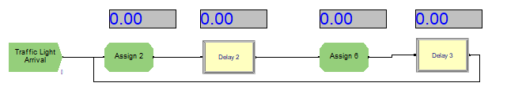

Figure 5.1 : Logic of traffic light

Figure 5.2 : Logic of flow vehicle at Dinh Bo Linh Route

Figure 5.3: Logic of flow vehicle starting at East Bach Dang Route

Figure 5.4 : Logic of flow vehicle starting at West Bach Dang Route

Figure 5.5 : Flow of station connected by routes

***5.1.1. Traffic light operation***

Table 5.1: Logic and modules of Traffic light operation

|  |  |  |  |
| --- | --- | --- | --- |
| **Activities** | **Logic** | **Module** | **Display** |
| Traffic light operation for vehicles arrival | To create the operation of traffic light when the vehicles move to it:   * Name: Traffic Light Arrival * Entities per arrival: 1 * Max arrival: Infinite * Time between Entities: 9999 hours   There are 2 conditions when the vehicles go through the intersection. The condition can be normal or there will be some unexpected events happening (traffic congestion, accident). We suppose that there is 80% of normal condition and 20% of unexpected condition:   * Type: Attribute * Attribute name: event_traffic * New Value: DISC (0.8,1,1.0,2)   Display Blue ball when vehicles move to this stage:   * Type: Picture * Entity Picture: Picture.BlueBall   The operation of traffic light will depend on different period of time:   * Type: Attribute * Attribute name: period * New value: AINT(TNOW+1)   The traffic light will become green:   * Type: variable * Variable name: BD light * Value: 1   When the traffic light is green, it will move to this stage, the value of processtime is identified on Expression:   * Name: Delay 2 * Delay time: processtime(period,1)*event_traffic   After the end of the green light, the red light appears:   * Type: Variable * Variable Name: BD light * New Value: 2   When the light becomes red, the flow will display Red ball:   * Type: Entity picture * Entity picture: Picture.RedBall   When the traffic light is red, it will move to this stage, the value of processtime is identified on Expression:   * Name: Delay 3 * Delay time: processtime(period,1)*event_traffic   The operation of the traffic light for vehicles arriving will continuously circulate like this flow. | **<Create>**  **<Assign>**  **<Delay>** | Table B  Table C  Table E  Table F  Table J  Table Q |

***5.1.2. Flow for vehicle starting at Dinh Bo Linh Route***

Table 5.2: Logic and modules of the flow for vehicle starting at Dinh Bo Linh Route

|  |  |  |  |
| --- | --- | --- | --- |
| **Activities** | **Logic** | **Module** | **Display** |
| Scheduling for vehicles arrival at Dinh Bo Linh Route | To create vehicles arriving based on a predetermined schedule:   * Schedule name: Schedule DBL * Entities per arrival: 1 * Max arrival: Infinite   There are 3 types of vehicles on the road: car, motorbike and bus. We suppose there will be 16% of car, 78% of motorbike, and 6% of bus   * Type: Attribute * Attribute name: Vehicle index DBL * New value: DISC (0.16,1,0.94,2,1,3)   For the traffic rules, when the motorbikes meet a red light, if they want to move the right, they can go immediately. If they go straight ahead, they have to wait. We suppose 60% of going straight ahead and 40% of turning right.   * Type: Attribute * Attribute name: Vehicle Turning Right index * New value: DISC (0.6,1,1,2)   Decide whether the vehicles have to wait for traffic light, If the vehicles turn right or the traffic light is green, they can move. Otherwise, they have to wait:   * Name: Decide 1 * Type: 2-way by condition * Value: Vehicle Index DBL == 2 && Vehicle Turning Right Index == 2   If two conditions listed before don’t happen, then the vehicles have to wait until the light turning green:   * Name: Hold 1 * Type: Scan for condition * Condition: BD light == 2   There will be 3 options that vehicles can move: 45% turning right Bach Dang Route, 10% going straight ahead, 45% turning left Bach Dang Route:   * Name: Which direction ? * Type: N-way by Chance.   Times for changing lane to Right Bach Dang Route is 100 seconds:   * Name: Right BD Route * Route time: 100 (seconds) * Destination Type: Station * Station name: Right BD   Times for moving straight ahead is 100 seconds:   * Name: Straight DBL Route * Route time: 100 (seconds) * Destination Type: Station * Station name: Straight DBL   Times for changing lane to Left Bach Dang Route is 100 seconds:   * Name: Left BD Route * Route time: 100 (seconds) * Destination Type: Station * Station name: Left BD | **<Create>**  **<Assign>**  **<Hold>**  **<Decide>**  **<Route>**  **<Schedule>** | Table B  Table D  Table J  Table J  Table K  Table L  Table M  Table P  Table Q |

***5.1.3. Flow for vehicle starting at East Bach Dang Route:***

Table 5.3: Logic and modules of the flow for vehicle starting at East Bach Dang Route

|  |  |  |  |
| --- | --- | --- | --- |
| **Activities** | **Logic** | **Module** | **Display** |
| Scheduling for vehicles arrival at East Bach Dang Route | To create vehicles arriving based on a predetermined schedule:   * Schedule name: Schedule BDD * Entities per arrival: 1 * Max arrival: Infinite   There are 3 types of vehicles on the road: car, motorbike and bus. We suppose there will be 12% of car, 81% of motorbike, and 7% of bus   * Type: Attribute * Attribute name: Vehicle index BDD * New value: DISC (0.12,1,0.93,2,1,3)   For the traffic rules, when the motorbikes meet a red light, if they want to move the right, they can go immediately. If they go straight ahead, they have to wait. We suppose 60% of going straight ahead and 40% of turning right.   * Type: Attribute * Attribute name: Vehicle Turning Right index * New value: DISC (0.6,1,1,2)   Decide whether the vehicles have to wait for traffic light, If the vehicles turn right or the traffic light is green, they can move. Otherwise, they have to wait:   * Name: Decide 1 * Type: 2-way by condition * Value: Vehicle Index DBL == 2 && Vehicle Turning Right Index == 2   If two conditions listed before don’t happen, then the vehicles have to wait until the light turning green:   * Name: Hold 3 * Type: Scan for condition * Condition: BD light == 1 * There will be 3 options that vehicles can move: 10% turning right Dinh Bo Linh Route, 90% going straight ahead to BDT Route * Name: Decide 4 * Type: 2-way by Chance.   Times for changing lane to Right Dinh Bo Linh is 100 seconds:   * Name: Right DBL Route * Route time: 100 (seconds) * Destination Type: Station * Station name: Right DBL   Times for moving straight ahead is 100 seconds:   * Name: Straight BDT Route * Route time: 100 (seconds) * Destination Type: Station * Station name: Straight BDT | **<Create>**  **<Assign>**  **<Hold>**  **<Decide>**  **<Route>**  **<Schedule>** | Table B  Table D  Table H  Table J  Table K  Table L  Table M  Table P  Table Q |

***5.1.4. Flow for vehicle starting at West Bach Dang Route:***

Table 5.4: Logic and modules of the flow for vehicle starting at West Bach Dang Route

|  |  |  |  |
| --- | --- | --- | --- |
| **Activities** | **Logic** | **Module** | **Display** |
| Scheduling for vehicles arrival at West Bach Dang Route | To create vehicles arriving based on a predetermined schedule:   * Schedule name: Schedule BDT * Entities per arrival: 1 * Max arrival: Infinite   There are 3 types of vehicles on the road: car, motorbike and bus. We suppose there will be 10% of car, 83% of motorbike, and 7% of bus   * Type: Attribute * Attribute name: Vehicle index BDT * New value: DISC (0.10,1,0.93,2,1,3)   For the traffic rules, when the motorbikes meet a red light, if they want to move the right, they can go immediately. If they go straight ahead, they have to wait. We suppose 60% of going straight ahead and 40% of turning right.   * Type: Attribute * Attribute name: Vehicle Turning Right index * New value: DISC (0.6,1,1,2)   The vehicles have to wait until the light is green:   * Name: Hold 4 * Type: Scan for condition * Condition: BD light == 1   There will be 2 options that vehicles can move: 90% going straight ahead to Bach Dang Dong Route, 10% turning left to Dinh Bo Linh Route   * Name: Which direction 3 ? * Type: 2-way by Chance.   Times for changing lane to Left Dinh Bo Linh Route is 100 seconds:   * Name: Left DBL Route * Route time: 100 (seconds) * Destination Type: Station * Station name: Left DBL   Times for moving straight ahead is 100 seconds:   * Name: Straight BDD Route * Route time: 100 (seconds) * Destination Type: Station * Station name: Straight BDD | **<Create>**  **<Assign>**  **<Hold>**  **<Decide>**  **<Route>**  **<Schedule>** | Table B  Table D  Table G  Table J  Table K  Table L  Table M  Table P  Table Q |

***5.1.5. Flow of stations connected by routes***

Table 5.5: Logic and modules of flow of stations connected by routes

|  |  |  |  |
| --- | --- | --- | --- |
| **Activities** | **Logic** | **Module** | **Display** |
| Vehicles moving on to the willing ways | After moving through the intersection, the vehicles will move on to route that they want to. Here are 7 routes for vehicles moving from different directions of intersection:  Name:   * Right BD Station * Left BD Station * Straight BDT Station * Straight BDD Station * Straight DBL Station * Right DBL Station * Left DBL Station   Putting 7 record for counting the entity statistics, time arrival and time between of 7 routes:   * Name: * Record 1 * Record 2 * Record 3 * Record 4 * Record 5 * Record 6 * Record 7 | **<Station>**  **<Record>**  **<Dispose>** | Table N  Table O  Table P |

## Verification and Validation

### *Verification*

Verification is to check whether the model is working correctly according to the mathematical model. After testing and testing, we found that the model is working according to the conceptualization model. Here's a video after we ran to see the flow of the entities. [Video](https://drive.google.com/file/d/1QfsuBXLwQ3OQmKltYpH7-klmynhU1AuO/view?usp=sharing)

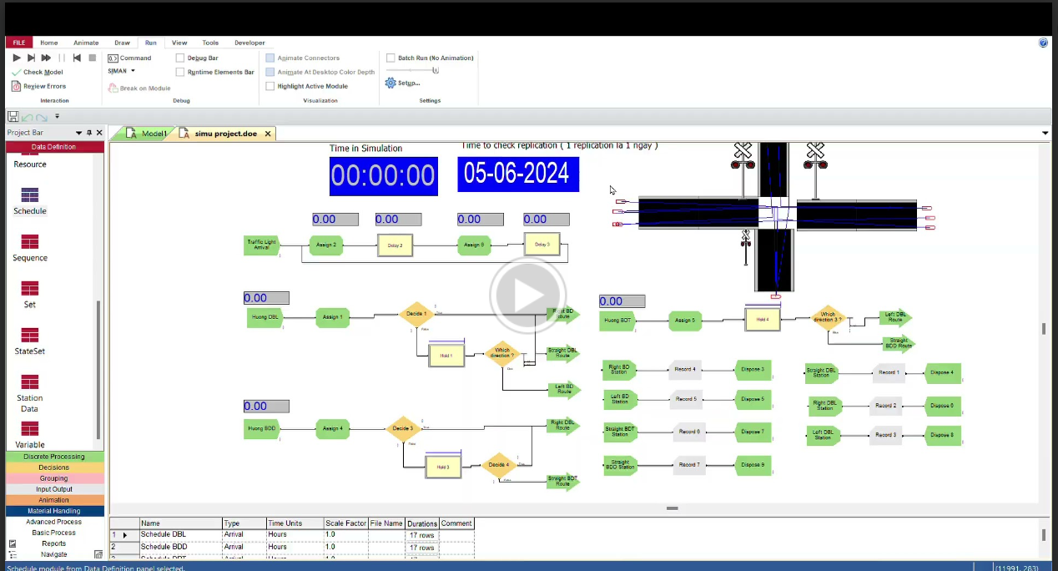

Figure 5.6 : The flow of the whole model

### *Validation*

#### Original result

After perfecting the model, we tested the results on the first run in 1 hour, and the results were as follows:

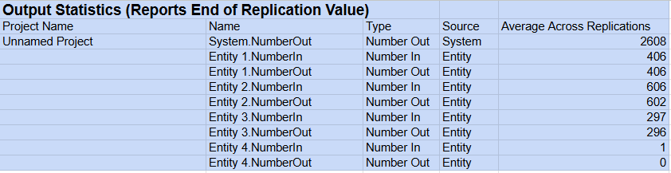

Figure 5.7 : Test model: Result in 1 hour run

However, it seems that the model is not reading exactly as much as we actually observed, the table below will be a way of calculating the difference between the actual result and the result of the ARENA run. To verify the validation of ARENA model, we have used the Mean Absolute Percentage Error (MAPE) to determine whether the model is valid or invalid. (MAPE) is a metric used to measure the accuracy of a forecast model, indicating the average percentage of forecast error. Specifically, MAPE is the average of the absolute error percentages between the actual and forecast values.

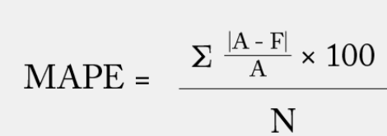

Figure 5.8 : MAPE formula

Table 5.6: Compare the difference between real and platform results

|  |  |  |  |  |  |
| --- | --- | --- | --- | --- | --- |
| **Test in 1 hour** | | | | | |
|  | Y | Y test | (Y-Ytest)/Y | MAPE | MAPE |
| DBL | 2255 | 406 | 0,8199556541 | 0,7533923961 | 75,34% |
| East BD | 1707 | 602 | 0,647334505 |  |  |
| West BD | 1434 | 297 | 0,7928870293 |  |  |

It can be seen that the MAPE is equal to 75.34%, a big deviation from the model that the team is wanting, so the team has revised the model and found a way to improve.

#### Improvement

Re-evaluating the model, we realized, it seems that the input data in the create block is incorrect. The use of exponential distribution seems to make the reading model inaccurate.

Figure 5.9 : <Schedule Module > Declare total vehicle per hour



Thinking about the results in the input analyzer, we put those values for each type of car into ARENA. Specifically, we declare 3 more variables "Vehicle Index + name route." Create a module to edit the time from the schedule to random expo(1 hour). For example, on the Dinh Bo Linh route, the vehicle index DBL will record 3 distributions in the intrinsic value (which is understood that, in 1 day, the average traffic will be).

Figure 5.10 : <Variable Module> Try to assign distribution from input analyzer

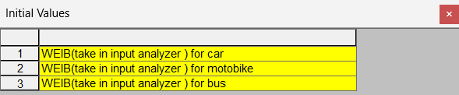

However, for some reason, the value in the initial value can't be declared as a distribution, and moreover, we don't want to smooth the data that way, so this adjustment can't be used.

We decided to use the simplest way, declaring the value directly into the schedule block, keeping the rest of the logic:

Figure 5.11 : < Schedule module > Adjustment values in schedule module

Declare all the total number of vehicles as shown below. And when running, we noticed a marked improvement in recording the number of vehicles entering and exiting at 3 points of the route. The report below will explain that in more detail.

The report exported from ARENA stated that the number of vehicles moved in the system when the model is run has a slight difference from the observed data that we have collected.

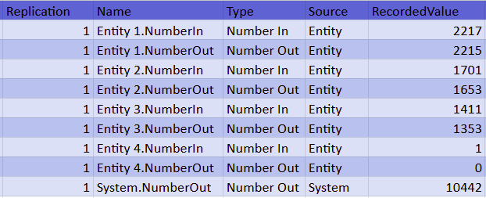

Figure 5.12 : Test model : Improvement result by changing parameters.

We set the output in the report to be the expected value and the data we collected previously to be the observed value. Consequently, we calculate the MAPE with the formulation below:

|  |  |  |
| --- | --- | --- |
| Observed | Expected |  |
| 2255 | 2215 | 0,0177383592 |
| 1434 | 1653 | 0,1527196653 |
| 1707 | 1353 | 0,2073813708 |
|  | Total | 0,3778393953 |

Table 5.7: MAPE calculation

We obtain the MAPE = $\frac{0,3778393953}{3}×100=12.59\%$

Evaluating the value of MAPE depends on the specific context and application area, although in this scenario the value varies from 10 to 20% can be acceptable. As a result, this model can be said to be valid.

#### Statistical Test

Another way to test the error is by testing the type I error using Kolmogorov-Smirnov (K-S) test to validate models by comparing the predicted and actual distributions. Eventually, K-S test is a more powerful test, useful when the sample size is smaller or equal to 20. Using the output report from the analyzer tool from previous section, we can use the K-S test value from the report to compare with the K-S critical value to determine whether the model is valid or not.

*Table 5.8: K-S statistics for each route*

|  |  |  |  |
| --- | --- | --- | --- |
| Route/Test statistic | South | East | West |
| Car | 0,171 | 0,258 | 0,258 |
| Motorbike | 0,258 | 0,258 | 0,258 |
| Bus | 0,258 | 0,258 | 0,258 |
| K-S critical value | 0,318 | 0,318 | 0,318 |
| Result | Accepted | Accepted | Accepted |

With the result obtained, we can conclude that the input values follow exponential distribution.

## Experimental and output analysis

From the results in the validation section, we continue to simulate the model in 1 day and 1 week, with initial conditions being the confidence level: 95%.

**Analyze in 1 day:**

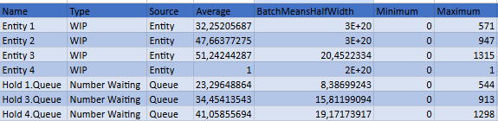

*Figure 5.12: Continuous Time Stats By Rep*

The average vehicle per second is 32 vehicles / second, and in some times, it reaches over 500 vehicles / second. The average vehicle at a traffic light approaches 40 vehicles per period.

Figure 5.13: OutputStats By Rep

The total vehicle in one day is over 50000+ vehicles.

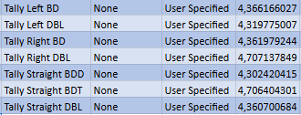

Figure 5.14 : Tally stat in stations

The tally record indicates the average vehicle going in which direction per second. This value approximately gets 4 entities / second.

By this sequence, we can observe the flow of vehicles per unit time. It is helpful to evaluate the performance of the road if new policies are applied. The observed vehicle in 1 week is an example.

**Analyze in 1 week:**

Keeping initial setting, the result in 7 replications, each replication has 17 hours from 6am to 10pm as follow in table.

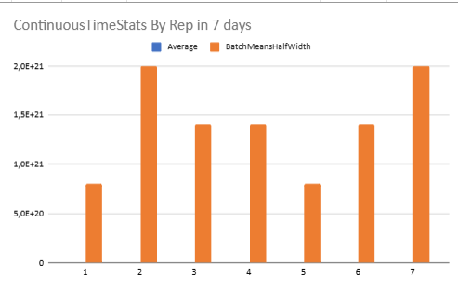

Figure 5.15: The fluctuate of transport population

The figure indicates the fluctuation of the transportation population between average WIP and holding queue per day. It has some peak days on Thursday and on the weekend. In the middle of the week, transportation is less crowded than other days.

Figure 5.16: Counter station in 7 days

This figure shows the number of entities going in which direction. We can see the trend of vehicle go straight into West Bach Dang and go straight in East Bach Dang. This is acceptable because this road connects to Hang Xanh Intersection and other important routes in Binh Thanh district.

## Result Discussion and Implications

**5.4.1 Result Discussion and Implifications**

In total, it can be seen that to accurately assess the traffic situation at the intersection is quite difficult. Through analyzes in the process analyzer and changes to the values ​​in the module, they can select a tip that evaluates the information traffic condition so that appropriate adjustments can be made. That is very suitable for developers to manage traffic infrastructure, so they will be able to distribute resources accordingly.

However, in reality, sometimes there needs to be a trade-off between factors in consideration of many other factors besides the direct factors, doing so in these traffic calculations requires careful consideration. Carefully consider both the traffic system and other factors so that the most reasonable balance can be achieved.

*Implications for traffic management:*

* Improved decision making: Analyzes from the process analyzer provide detailed and specific information about current traffic conditions. This information helps traffic managers have a clearer view of the current status and problems that need to be resolved, thereby making accurate and appropriate decisions.
* Resource allocation: With a clearer understanding of communication traffic and congestion, managers can allocate resources more effectively, consider adjusting signal timing, and re-arranging warning signs or even changing the information structure in the hottest spots to improve information retention.
* Policy development: Results from the analysis can play an important role in the development of new transportation policies. For example, vehicle traffic data can help inform policies about restricting vehicles at peak times or encouraging the use of public transport.
* Technology integration: Traffic analytics modules can integrate with existing intelligent transportation systems (ITS). This not only enhances traffic monitoring and management capabilities, but also creates favorable conditions for the development of automated and semi-automated traffic solutions in the future.

**5.4.2 Process Analyzer**

Process analyzer tools are essential in industrial and business environments for monitoring, analyzing, and optimizing operations. By testing seven available scenarios of traffic light time (in the range of 40 to 70 seconds) and three new scenarios (35, 75 and 30 seconds), our group has utilized the table as below (in Appendix). To determine the best scenario for peak hours with traffic jams at intersections, we prioritized minimizing queue wait times and queue numbers, as these factors were critical for managing congestion effectively. High throughput is also important but should not come at the cost of significantly increased wait times or queue lengths, as this would worsen traffic jams. By comparing 4 elements such as entities’ total time, waiting time in queue, number of vehicles in queue and system throughput (System.NumberOut column), it is observed that scenario 10 yields the best result. Scenario 10 stands out with the highest throughput (8890), the lowest average queue waiting time (0.003), and the lowest total queue numbers (10.131).

However, in real-life situations, traffic light time sometimes cannot be adjusted flexibly. Therefore, during peak hours at Bach Dang intersections, policemen usually coordinate the traffic flows, which means that they allow the vehicle flow to go sooner than the signal of traffic lights to avoid congestion.

# CONCLUSION

This study synthesizes the results from the analysis and optimization of traffic congestion at a single intersection using MATLAB and Arena simulation. It emphasizes the importance of effective traffic management strategies to alleviate congestion, examines the causes and effects of traffic congestion in Vietnam, particularly how it affects daily life and economic activities. The study highlights the utility of simulation tools like MATLAB and Arena in modeling and improving traffic flow. It suggests areas for future research, such as exploring advanced algorithms and integrating real-time data for dynamic traffic control systems.

For further research, this study could also expand the scope of the simulation to include multiple intersections and varied traffic scenarios could provide a more comprehensive understanding of traffic dynamics across a larger network. Moreover, investigating the environmental impact of optimized traffic flow can be added, such as reductions in vehicle emissions due to decreased idle times, could be a valuable area of study. Furthermore, research into the user experience of drivers and pedestrians with the optimized traffic system could provide insights into the practical implications of the proposed solutions.

# REFERENCES

Traffic Flow Theory: A State-of-the-Art Report" by the Transportation Research Board (TRB)

Modeling and Simulation of Traffic Flow and Traffic Management by Peter Wagner (2012

Roy, R., Ghosh, S. K., Zoha, N., & Islam, M. A.-U. (2020). ANALYSIS AND OPTIMIZATION OF TRAFFIC CONGESTION AT SINGLE INTERSECTION USING MATLAB AND ARENA SIMULATION. *ITEGAM-JETIA*, *6*(23), 34-40. Retrieved from <http://itegam-jetia.org/journal/index.php/jetia/article/view/640>.

Sayed, S.A., Abdel-Hamid, Y. & Hefny, H.A. Artificial intelligence-based traffic flow prediction: a comprehensive review. *Journal of Electrical Systems and Inf Technol* 10, 13 (2023). <https://doi.org/10.1186/s43067-023-00081-6>.

Bhadra, S., Kundu, A., Khatua, S. (2021). Optimization of Road Traffic Congestion in Urban Traffic Network Using Dinic’s Algorithm. In: Abraham, A., Sasaki, H., Rios, R., Gandhi, N., Singh, U., Ma, K. (eds) Innovations in Bio-Inspired Computing and Applications. IBICA 2020. Advances in Intelligent Systems and Computing, vol 1372. Springer, Cham. [https://doi.org/10.1007/978-3-030-73603-3](https://doi.org/10.1007/978-3-030-73603-3_34)

# APPENDIX

**Data Set**

Access full data set in the link: [Data input excel.xlsx](https://mphcmiuedu-my.sharepoint.com/:x:/g/personal/ielsiu21357_student_hcmiu_edu_vn/EW8yfb6BX9pBhY2ZZECd3a8B9JpmgNscABBI2TTNKCbz8g?e=KQmmoj)

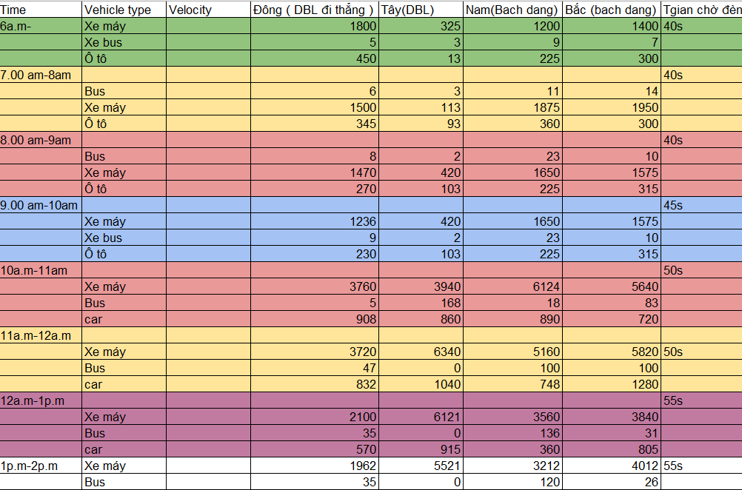

Table A: < Data Input >

**Display**

Table B : <Create Module>

Table C :<Flow of traffic light>

*Table D: < Assign Module in Arrival Vehicle>*

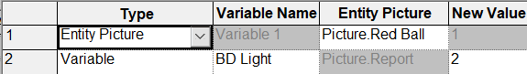

*Table E and F: < Assign Module in traffic light >*

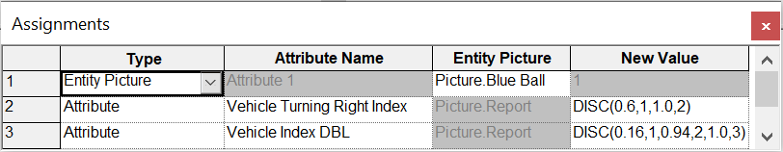

*Table G : < Assign Module in Huong DBL >*

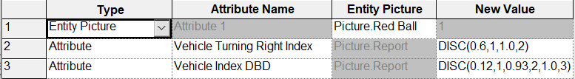

Table H: < Assign module in Huong BDD >

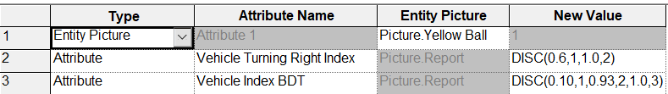

Table I: < Assign module in Huong BDT >

*Table J: < Delay Module >*

*Table K: < Decide Module >*

*Table L: < Hold Module >*

*Table M: < Route Module >*

*Table N: < Station Module >*

*Table O: < Record Module >*

*Table P: < Dispose Module >*

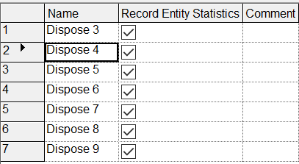

*Table Q: < Schedule Module >*

*Table R: < Variable Module >*

*Table S: < Animation >*

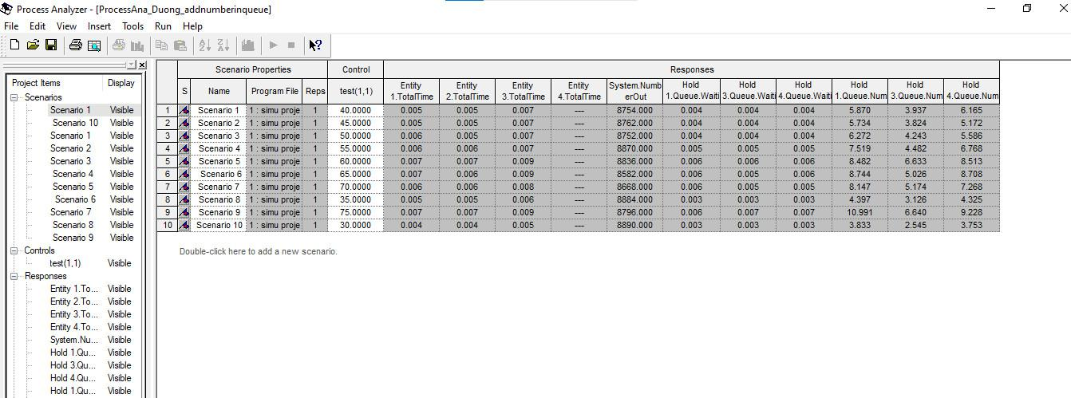

*Table T: <Process Analyzer>*